**RESIDENTIAL REAL ESTATE AND THE WEATHER: FINDINGS**

Data Analytics Bootcamp (Class 2)

Wednesday, November 13, 2019

Team : Kaveh Amini, Yashwinie Shivanand, Yinka Adesanmi

Region: King County, Washington State, United States

Datasets: 2014-2015 home sales in King County, WA (.csv) and 2014-2015 historic weather for King County, WA (api, json)

**(I) What is the correlation between home purchases (yes or no) and different weather seasons?**

Analysis: We plotted average home selling prices by day and by month against average temperature per day and month. In addition, we plotted average house prices against other weather-related factors like humidity, cloud cover, and wind speeds. Temperature and weather-related factors were also plotted against counts of homes sold by day and by month.

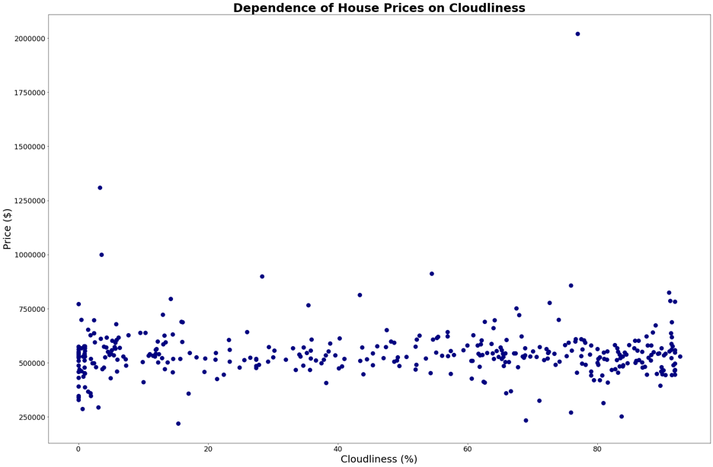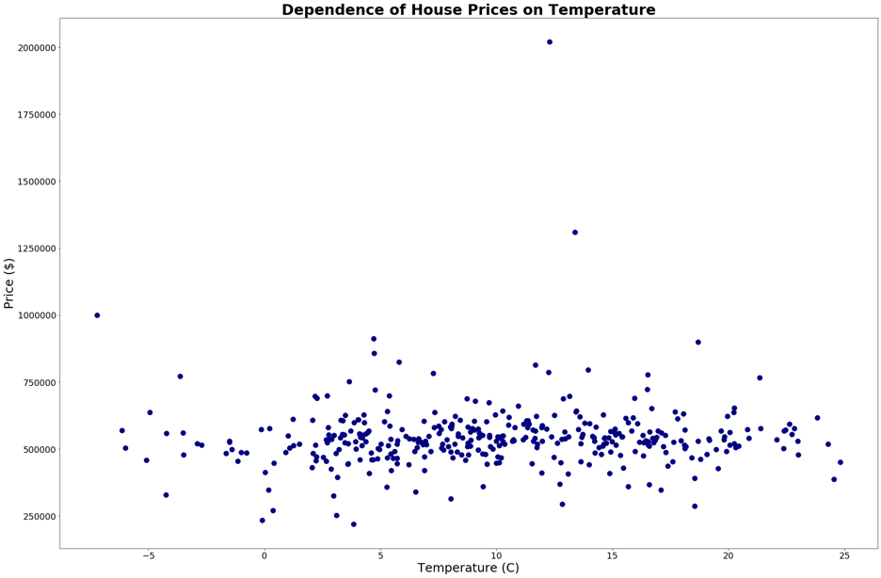

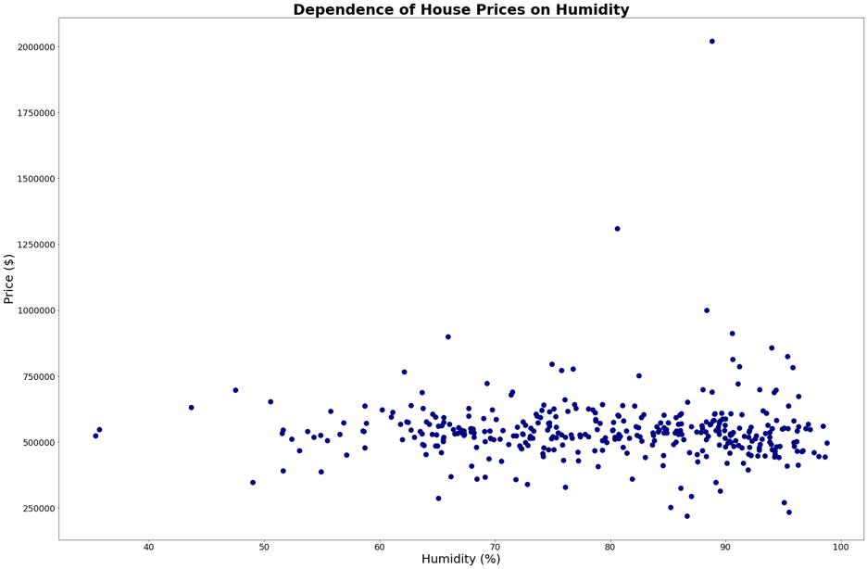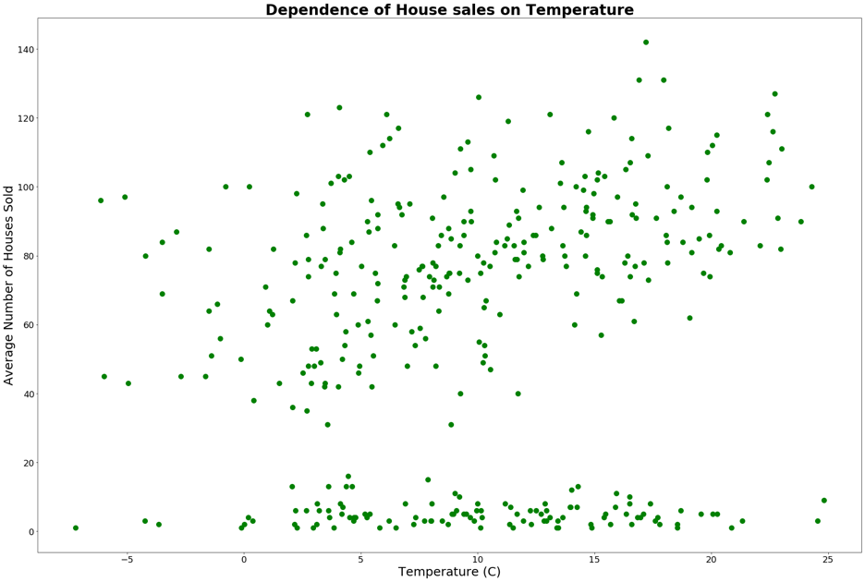

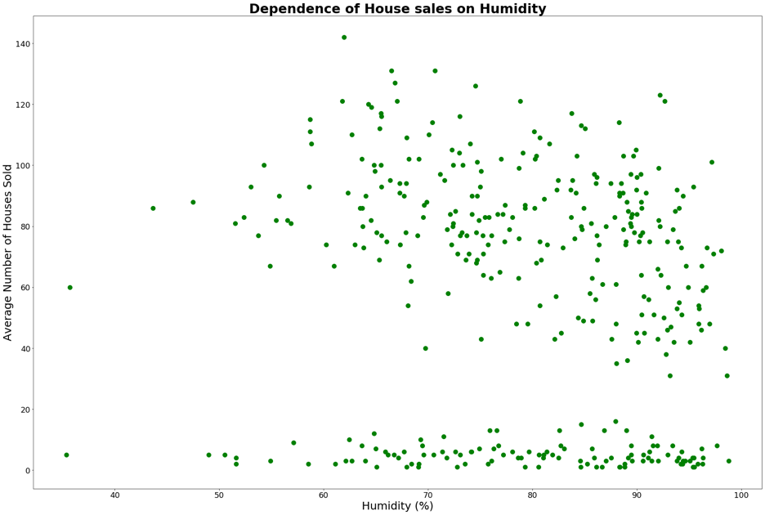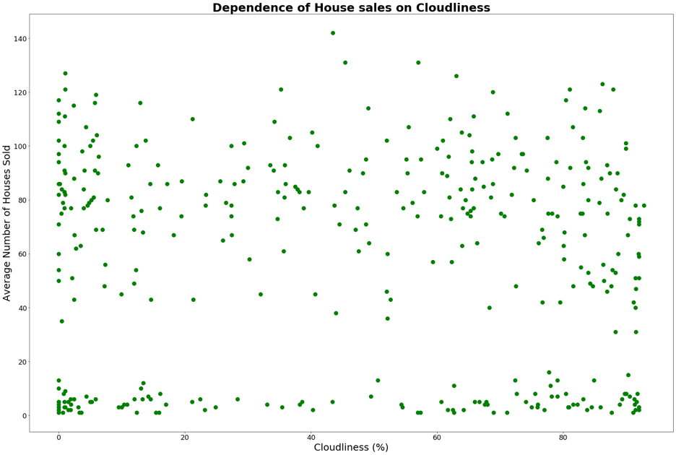

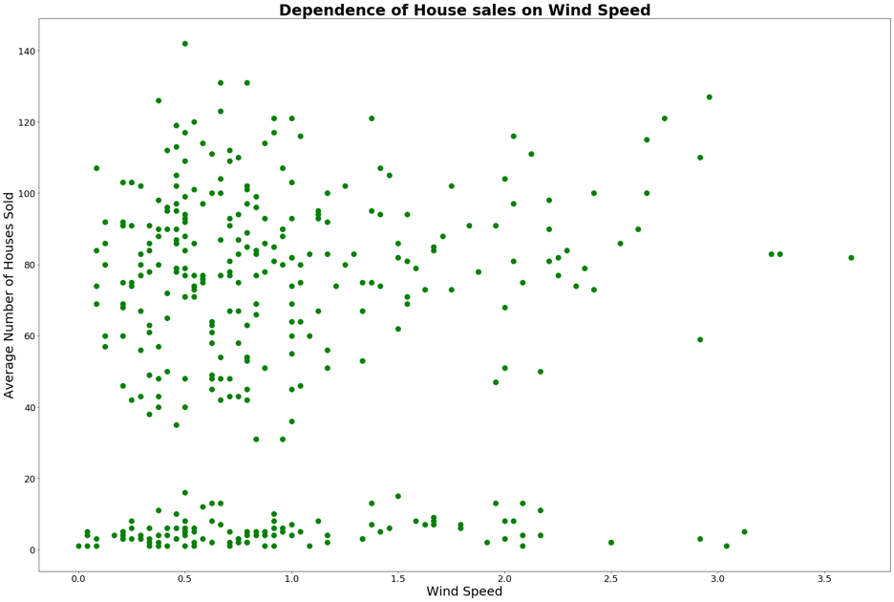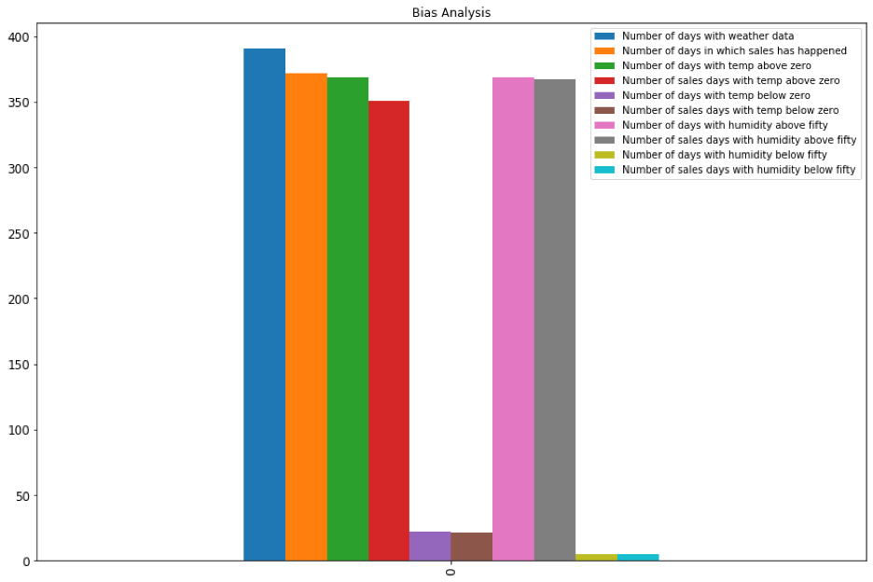

Findings: There does not appear to be any relationship between weather (specifically temperatures) and a person’s choice to purchase a home in the King County area. To check for bias, we looked at the number of days that a certain weather factor exists, to then compare with the occurrence of home sales in the geographic region on those days. This led to the realization that King County might likely possess a temperate unchanging climate, thus leading to the lack of correlation between home sale prices or home sale counts with the area’s weather. Ideally, if the open dataset existed, we would like to compare these findings with another region with more distinct seasonal weather changes.

**(II) Is there a correlation between different number of rooms and builds of homes sold in King County?**

Analysis: We plotted the selling price of homes in King County against the year it was built, its number of bedrooms, its square feet, lot size, basement size, and number of floors.

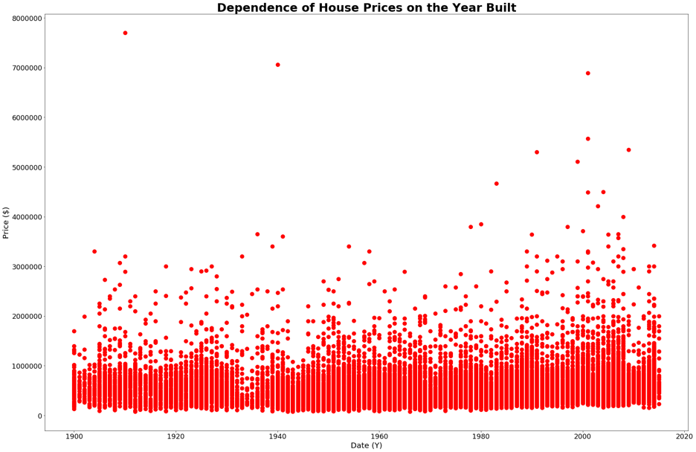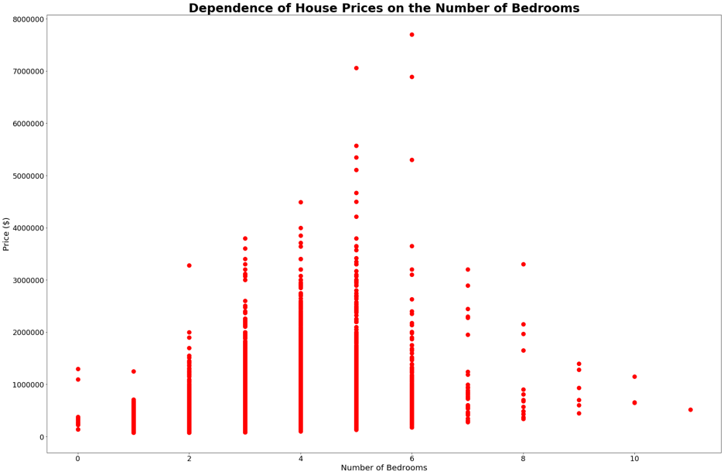

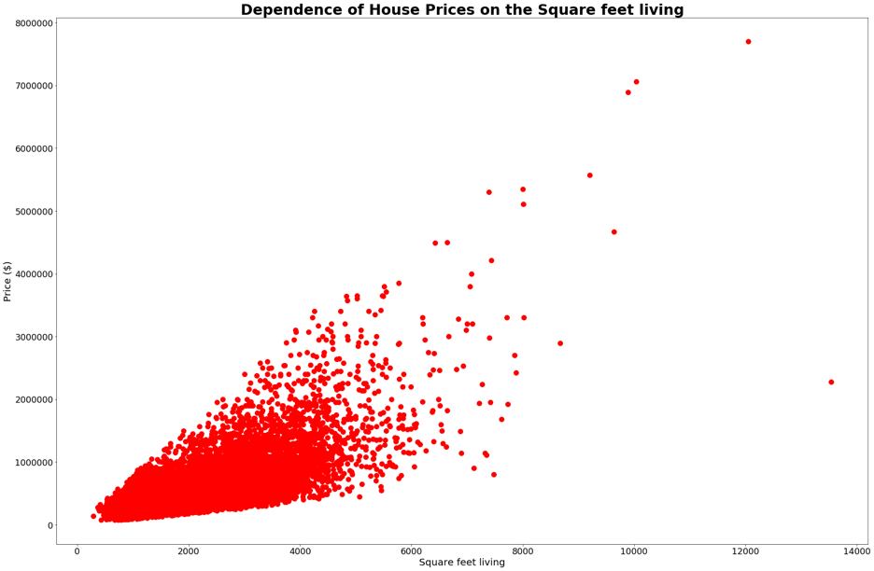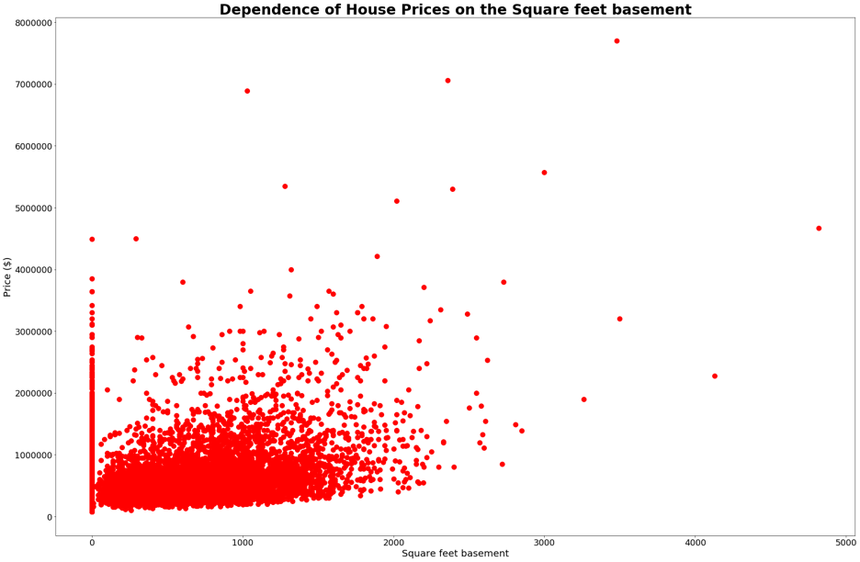

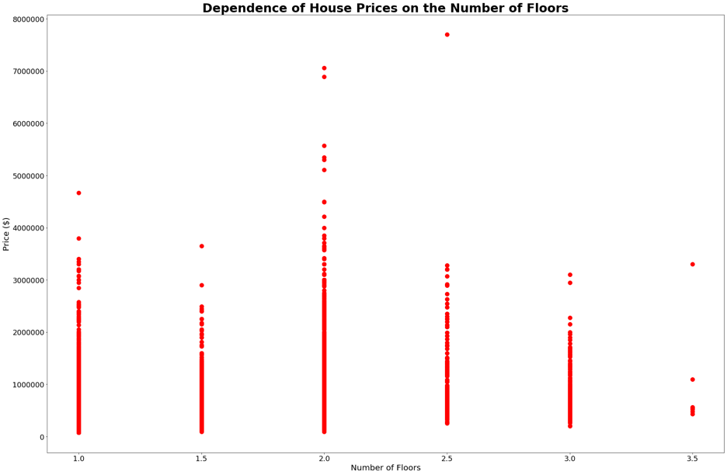

Findings:

A correlation is evident between home prices and the building’s features and build year. There is a weak relationship between the year a house was built and its price. Only some newly built houses have higher prices.

It also appears there is a correlation between home prices and square footage of the property living area and basement, the higher the square footage the higher the home prices generally.

The correlation between the number of bedrooms and the price also is weak. The houses with 5 and 6 bedrooms have higher prices in general.

The number of floors also does not have a strong correlation with the price and the houses with two floors have higher prices in general.